Use Case Report



# **1. Use Case Diagram**

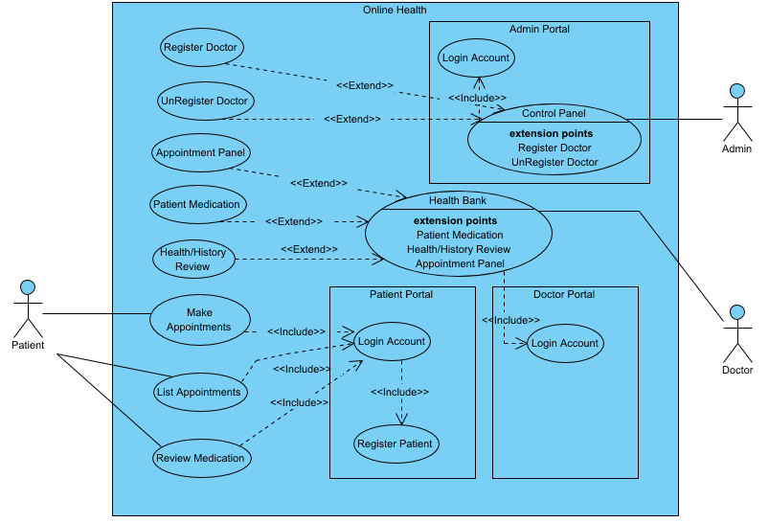

# **2. Prioritized Use Cases**

| **Name** | **Description** | **Priority** | **Size** | **Complexity** |
| --- | --- | --- | --- | --- |
| Register Doctor | Admin Inserts Doctor to the system | Must | Medium | Low |
| Control Panel | Admin Inserts or Removes Doctor from the System | Must | Medium | Medium |
| Login Account | Admin Logins | Must | Small | Medium |
| Login Account | Patient Logins | Must | Small | Medium |
| Register Patient | Patient Register to the System | Must | Small | Medium |
| List Appointments | Patient Make or Unset Appointments | Must | Medium | Medium |
| Patient Medication | Doctor Prescription | Must | Medium | Medium |
| Health/History Review | Doctor Review Patient's history | Must | Medium | Medium |
| Review Medication | Patient follows medication instruction from doctor | Must | Medium | Medium |
| Make Appointments | Patient Make Appointments | Must | Medium | Medium |
| UnRegister Doctor | Remove Doctor from the system | Must | Medium | Medium |
| Login Account | Doctor Logins | Must | Medium | High |
| Health Bank | Doctor main panel for interaction to Patients | Must | Medium | High |
| Appointment Panel | Doctor See upcoming Appointments and sets availability for new ones | Must | Medium | High |